CHAPTER 4: Chemical patterns

Worksheet 4.9

Chemical formulae
Answers

Covalent compounds
1. Complete the table by writing the chemical formula of the covalent compound formed from the listed elements.
Element 1 | Element 2 | Formula | Name of compound
Nitrogen | Chlorine | NCl₃ | Nitrogen trichloride
Sulfur | Oxygen | SO₃ | Sulfur trioxide
Carbon | Sulfur | CS₂ | Carbon disulfide
Carbon | Oxygen | CO | Carbon monoxide
Phosphorus | Oxygen | P₂O₅ | Diphosphorus pentoxide
Carbon | Fluorine | CF₄ | Carbon tetrafluoride
Oxygen | Bromine | OBr₂ | Oxygen dibromide
Nitrogen | Oxygen | N₂O₄ | Dinitrogen tetroxide

Ionic compounds
2. Use the table of valencies in your textbook to complete the table by writing the chemical formula of the ionic compound formed from the listed elements. Name each compound.
Positive ion | Negative ion | Formula | Name of compound
Silver | Iodide | AgI | Silver iodide
Lead | Sulfide | PbS | Lead sulfide
Calcium | Nitride | Ca₃N₂ | Calcium nitride
Aluminium | Sulfide | Al₂S₃ | Aluminium sulfide
Barium | Nitrate | Ba(NO₃)₂ | Barium nitrate
Copper (II) | Sulfate | CuSO₄ | Copper (II) sulfate
Sodium | Phosphate | Na₃PO₄ | Sodium phosphate
Zinc | Hydrogen carbonate | Zn(HCO₃)₂ | Zinc hydrogen carbonate

Structural formulae
3. The structural formulae for various common compounds are shown. Write the molecular formula for each compound.
(a) Lactic acid (b) Butene (c) Hydrazine
 | 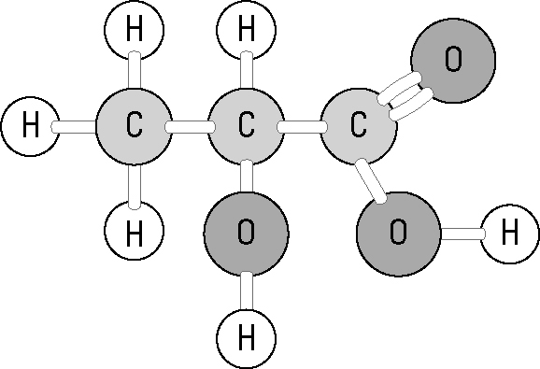 | 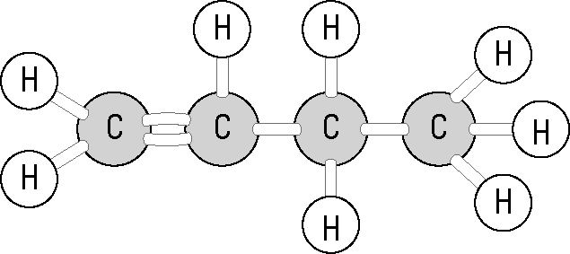  N₂H₄  C₄H₈ | 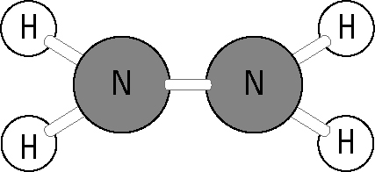
...................................... ...................................... ......................................
C₃H₆O₃

